**Database Management System - Spring 2023**

**Lab-03**

**Lab Task(s):**

1. Write a query to generate new names of the employees by combining the first 3 characters of the First_Name and last 3 characters of the job.

**select concat(left(first_name, 3), right(last_name, 3)) as "Employee New Name" from employees;**

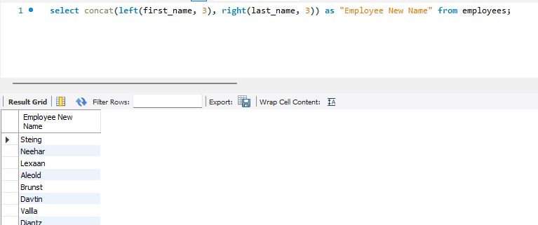

1. Generate new jobs for the employees by changing letter E with A in the existing jobs.

**select replace(job_id, "E", "A") as "New jobs" from employees;**

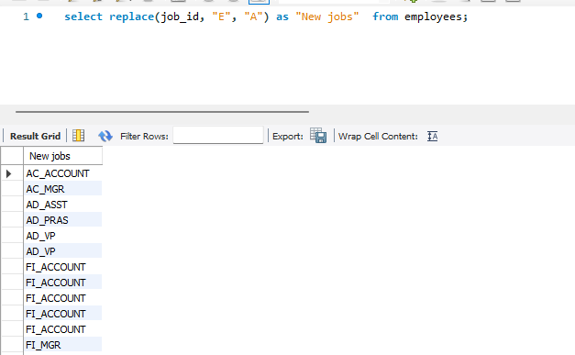

1. Write a query to Display Names, hire date years in the department.

**select first_name, last_name, date(hire_date) from employees;**

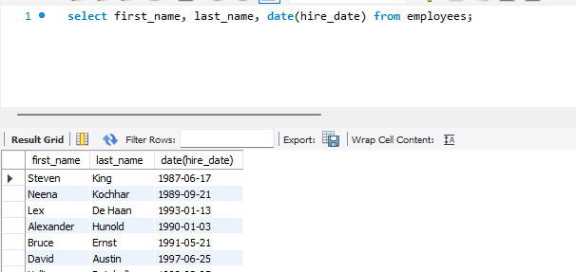

1. Write a query to display names, hire date of all the employees who were hired before July 30, 1987. Keeping this in mind that hire dates should be displayed in the format “MONTH DATE, YEAR”. Also date in the where clause should be in the format “MONTH DATE, YEAR”.

**SELECT concat(first_name, last_name) AS "Name : ", DATE_FORMAT(hire_date, '%M %e, %Y') AS hire_date**

**FROM employees**

**WHERE hire_date < STR_TO_DATE('July 30, 1987', '%M %e, %Y');**

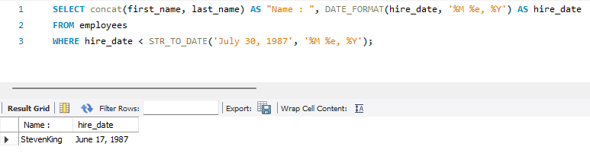

1. Write a query to display the last day of the current month & three months before the current month.

SELECT

LAST_DAY(CURRENT_DATE) as LastDayOfCurrentMonth,

LAST_DAY(DATE_SUB(CURRENT_DATE, INTERVAL 3 MONTH)) as LastDayOfThreeMonthsAgo;

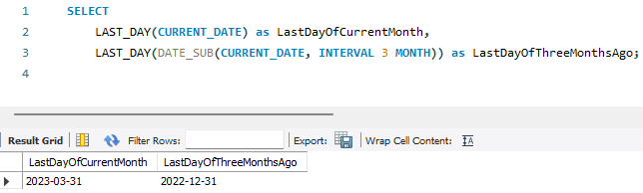

1. Write a query to get the day of the current year.

SELECT DAYOFYEAR(CURRENT_DATE) as DayOfYear;

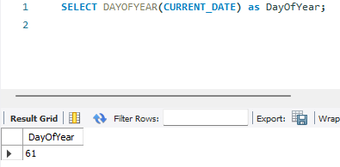

1. Write a query to get the current date in the following format.  
   Sample date : 2014-09-04

Output: September 4, 2014

SELECT DATE_FORMAT(CURDATE(), '%M %e, %Y') AS formatted_date;

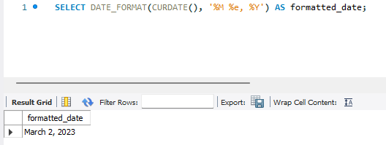

1. Write a query to get the current date in Thursday September 2014 format.

SELECT DATE_FORMAT(CURDATE(), '%W %M %Y') AS formatted_date;

1. Write a query to get the first name and hire date from employees table where hire date between '1987-06-01' and '1987-07-30'.

SELECT first_name, hire_date

FROM employees

WHERE hire_date BETWEEN '1987-06-01' AND '1987-07-30';

1. Write a query to display the current date in the 05/09/2014 format.

SELECT DATE_FORMAT(NOW(), '%m/%d/%Y') AS formatted_date;

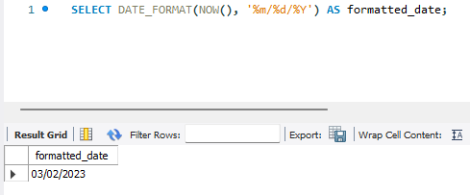

1. Write a query to get the first_name, last_name who joined in the month of June.

**select first_name, last_name from employees where month(hire_date) = 6;**

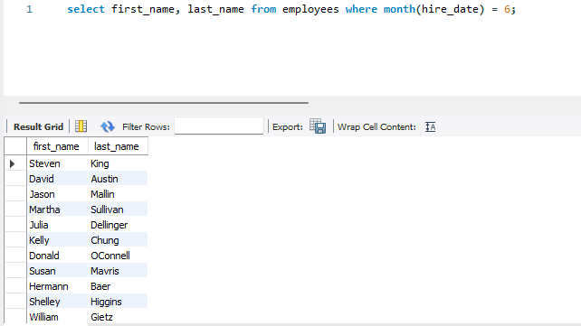

1. Write a query to append '@iba-suk.edu.pk' to email field.

**UPDATE employees SET email = CONCAT(email, '@iba-suk.edu.pk');**

1. Write a query to get the employee id, first name and hire month using MID().

**SELECT employee_id, first_name, MID(hire_date, 6, 2) AS hire_month**

**FROM employees;**

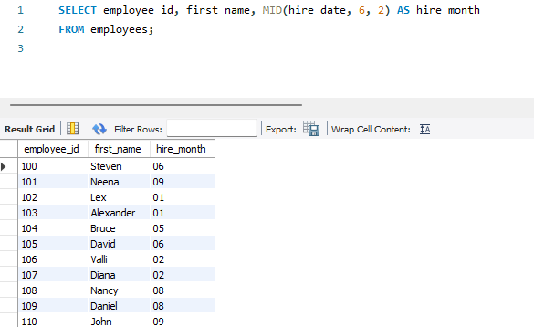

1. Write a query to extract the last 4 character of phone numbers.

**SELECT RIGHT(phone_number, 4) AS last_four_digits**

**FROM employees;**

1. Write a query to get the last word of the street address(from locations able).

**SELECT SUBSTRING_INDEX(street_address, ' ', -1) AS last_word**

**FROM locations;**

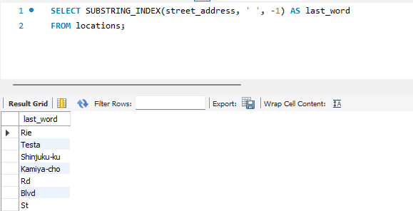

1. Write a query to get the locations that have minimum street length.(locations tbl).

**SELECT location_id, street_address**

**FROM locations**

**WHERE LENGTH(street_address) = (SELECT MIN(LENGTH(street_address)) FROM locations);**

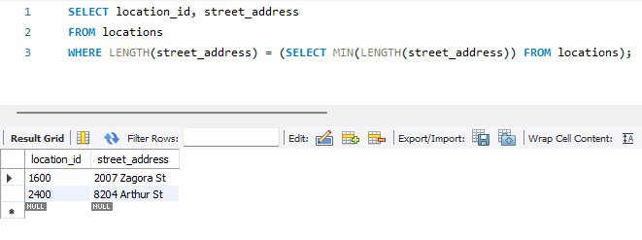

1. Write a query to display the first word from those job titles which contains more than one words.

**SELECT SUBSTRING_INDEX(job_title, ' ', 1) AS first_word**

**FROM jobs**

**WHERE job_title LIKE '% %';**

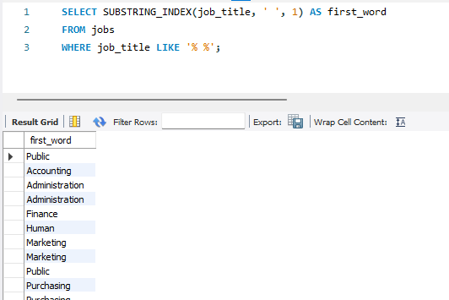

1. Write a query to display the length of first name for employees where last name contain character 'c' after 2nd position.

**SELECT LENGTH(first_name) AS first_name_length**

**FROM employees**

**WHERE SUBSTRING(last_name, 3) LIKE '%c%';**

